MY NOTES

TOOL REQUIRED

* PHP 7.4 thread safe
* Apache web server
* MySQL
* Composer

HOW TO SETUP

**## Apache Webserver ##**

- Download Apache

https://www.apachelounge.com/download/

- Copy Paste Apache24 Folder in C:/

- Open C:/Apache24/conf/httpd.conf

- Replace #ServerName www. ... with ServerName localhost

- Remove # in LoadModule rewrite... Line

- Open CMD in Administrator Mode

- Use the Command "cd /Apache24/bin"

- Use the Command "httpd -k install"

- Use the Command "httpd -k start"

**## PHP**

- Download PHP (thread safe)

https://windows.php.net/qa/

- Create Folder "php" in C:/

- Copy/Paste PHP in C:/php

- Rename C:/php/php.ini-development to C:/php/php.ini

-edit php.ini

Change Extension_dir = " ext" to Extension_dir = "C:\php\ext"

Uncomment the extensions below

extension=mysqli

extension=openssl

extension=pdo_firebird

extension=pdo_mysql

extension=pdo_oci

extension=pdo_odbc

extension=pdo_pgsql

extension=pdo_sqlite

- Open C:/Apache24/httpd.conf

- Add the Following Lines:

PHPIniDir "C:/php"

LoadModule php7_module "C:/php/php7apache2_4.dll"

AddHandler application/x-httpd-php .php

- Add index.php in "DirectoryIndex index.html" Line

- Open CMD in Administrator Mode

- Use Command "cd /Apache24/bin"

- Use Command "httpd -k restart"

**## MySQL Database**

- Download MySQL

dev.mysql.com/downloads/windows/installer/8.0.html

- Install By clicking Next next execute....

- Set Root Password

- Next Next Next

- Test your Database with Username "root" and your password

-run the provided MyNotesDB.sql schema

**## MyNotes Application**

**-** Download the source code

- Create a folder titled “SMN” inside the “C:\Apache24\htdocs\” directory

- extract the contents of MyNotes zip file to the SMN folder

**## Composer**

- Download and install composer

<https://getcomposer.org/>

- Open CMD as administrator

- Go to the MyNotes directory “C:\Apache24\htdocs\SMN” by typing “cd C:\Apache24\htdocs\SMN” in the command prompt

- install facebook sdk to the MyNotes application by typing “composer require facebook/graph-sdk” command

HOW TO USE MYNOTES

- Open any browser

- Type <http://localhost/SMN/index.php> in the address bar and press enter

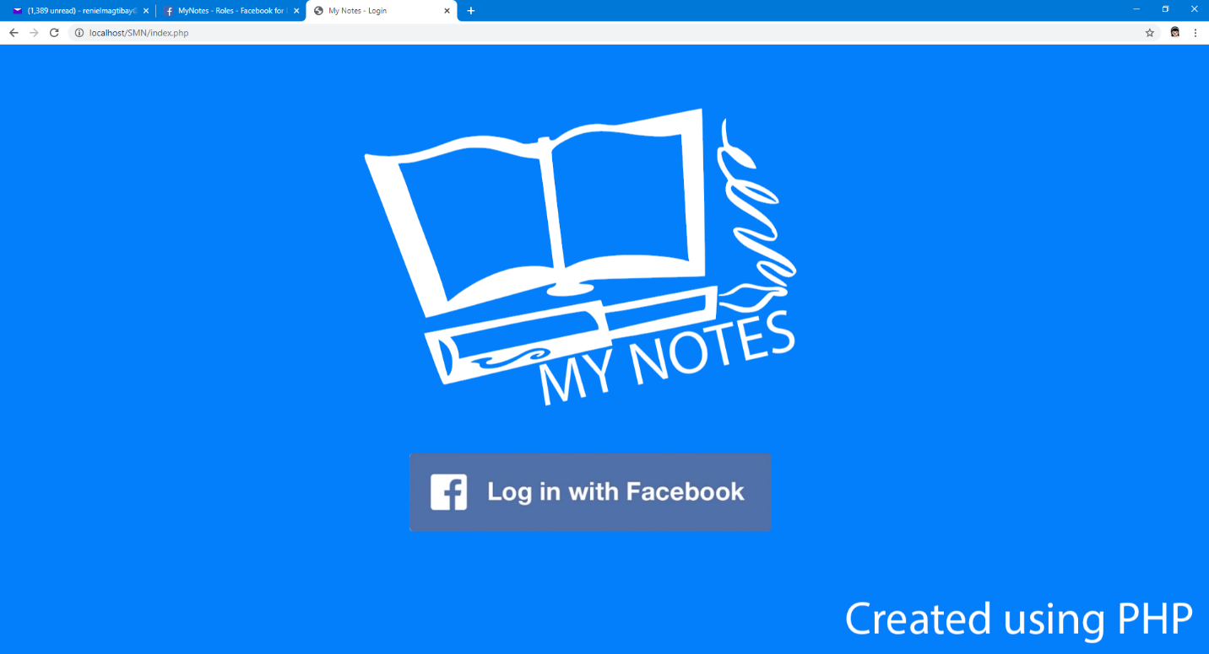

- Click the Log in with Facebook button

- Since this is a prototype app only facebook test accounts can be used to access it. You may use the credentials below for the testing accounts.

**fsxdeswwjy_1605354822@tfbnw.net**

**oveubnjsqs_1605354830@tfbnw.net**

**ftosyppreh_1605354825@tfbnw.net**

**fbzklgygsp_1605354827@tfbnw.net**

[**open_rlfethh_user@tfbnw.net**](mailto:open_rlfethh_user@tfbnw.net)

password for all the accounts provided is : **Test@123**

**-** You may create your first note by inputting the details in both the title and contents field. As per design for this prototype application, Title is limited to 255 characters which the contents is limited to 1024 characters. Once done encoding, click the new note button.

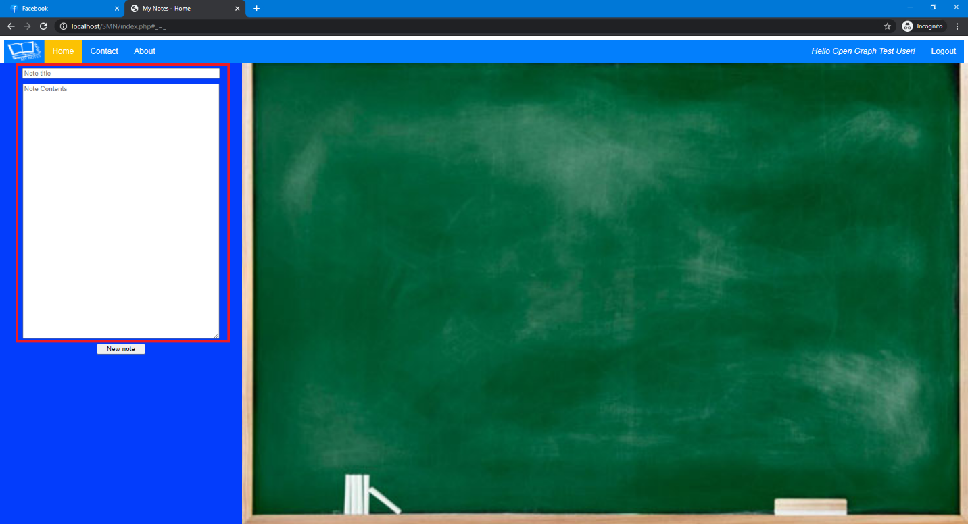

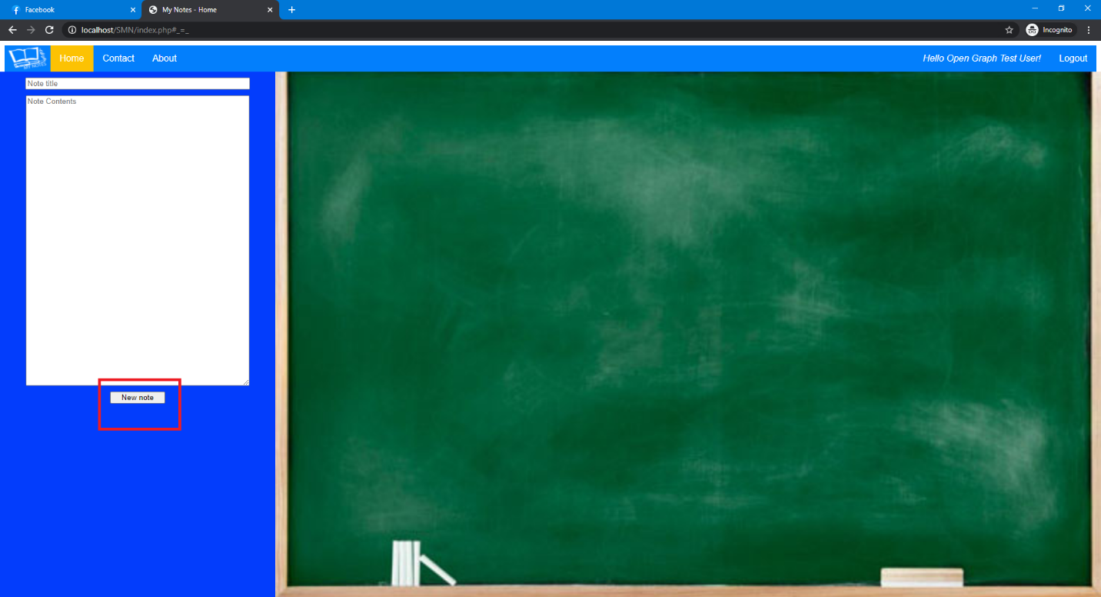

**-** The created note will appear in the blackboard on the right side of the screen.

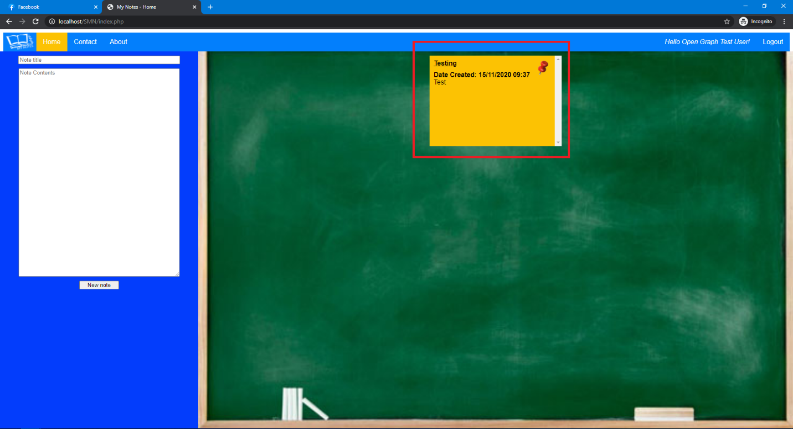

**-** An existing note can be edited by clicking its title. The existing contents of the note clicked will appear in the note contents field on the left side which can now be edited. Once done applying the desired update, click the update button to save the updated note.

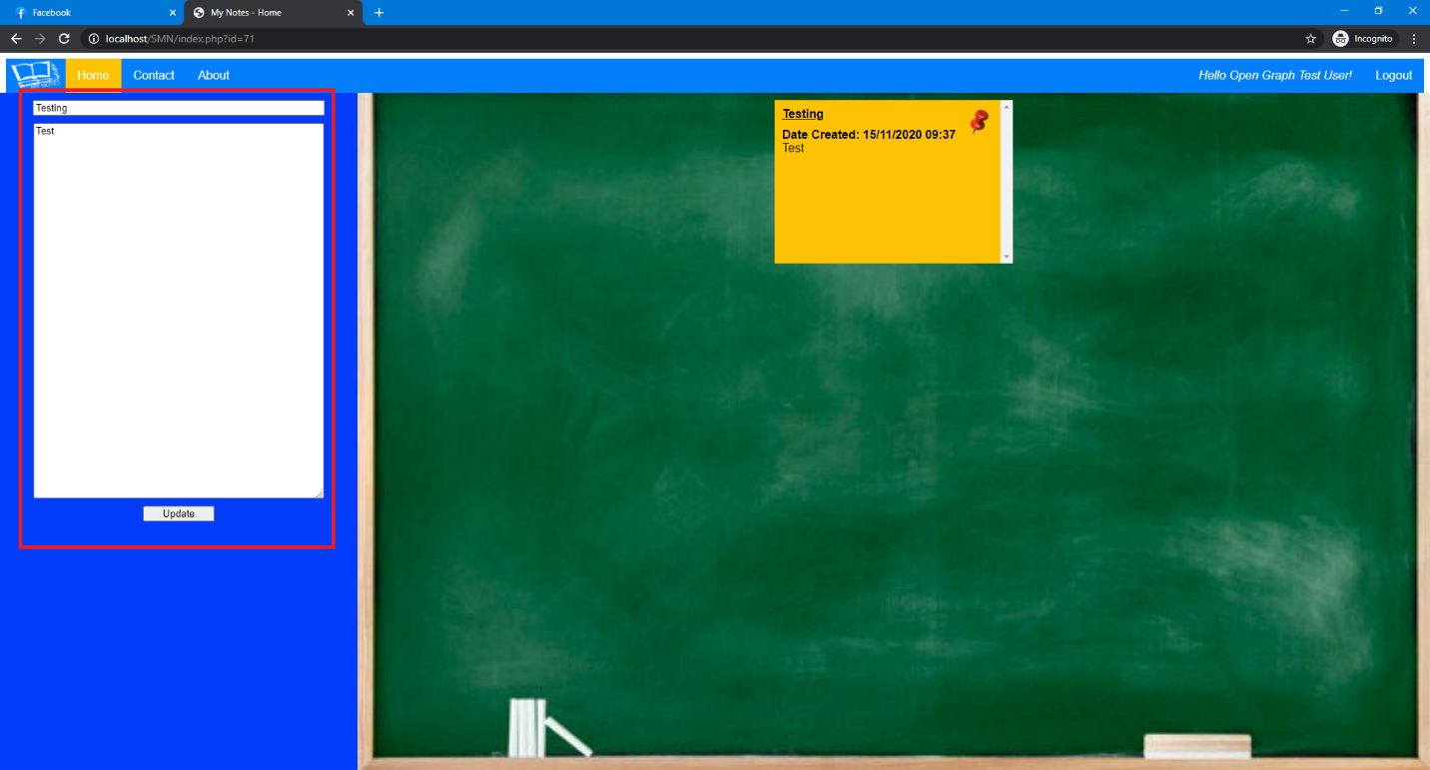

**-** To delete an existing note, click on the Pin icon in the upper right corner of the note

